SID-ME 1-page template

***John Doe*, S'chn-T' Gaii Spock*, Albert Bernstein**, Michiel Van Dousselaere *,\****

**\*University of Vienna, Austria, **Märklin, Germany**

*E-mail:* [*xxx.yyy@zzz.com*](mailto:xxx.yyy@zzz.com)

Pls. limit at 2500 characters: The display technology landscape is undergoing a transformative shift, driven by the rapid evolution of emissive displays. Emissive displays, including Organic Light-Emitting Diode (OLED) and microLED technologies, represent the cutting edge of visual innovation, offering unparalleled image quality, design flexibility, and energy efficiency. As consumer demand for brighter, more vibrant, and power-efficient screens continues to accelerate, these technologies are shaping the future of devices ranging from smartphones and televisions to wearables and large-format digital signage.

OLED displays, renowned for their deep blacks, high contrast ratios, and thin form factors, have already established a strong foothold in high-end consumer electronics. Meanwhile, microLEDs—composed of microscopic, self-emissive LEDs—are emerging as the next major leap forward. microLEDs promise superior brightness, longevity, and scalability, potentially overcoming some of OLED’s limitations such as burn-in and color aging. The ongoing development of new materials and manufacturing techniques is also paving the way for other innovative emissive display technologies, including quantum-dot LEDs (QLEDs) and hybrid approaches.

This comprehensive overview examines the fundamental principles underlying emissive display technologies, explores key advancements in device architectures and manufacturing processes, and assesses the competitive dynamics shaping the global market. It highlights the opportunities and challenges facing industry stakeholders, including supply chain considerations, technical hurdles, and evolving application areas. Through detailed analysis of current trends and future prospects, this report provides invaluable insights for technology developers, device manufacturers, investors, and anyone seeking to understand the business and technological drivers of the next generation of displays.

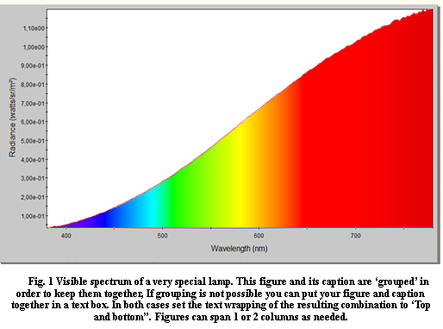

**Fig. 1. Visible spectrum of a very special lamp. 2..3 figures can be placed next to each other**

**Acknowledgements**

We gratefully acknowledge the contributions of our colleagues, industry experts, and partners whose insights and support have been invaluable in preparing this overview of emissive display technologies and markets

**References**

1. <http://en.wikipedia.org/wiki/Lorem_ipsum>
2. Hofstadter, D. R. "On Self-Referential Sentences," "On Self-Referential Sentences: A Follow-Up," and "On Viral Sentences and Self-Replicating Structures." Chs. 1-3 in Metamagical Themas: Questing of Mind and Pattern. New York: BasicBooks, pp. 1-69, 1985.
3. Howard W. Bergerson, “Palindromes and Anagrams”, Jun 1, 1973.